**Tutorial 05 –** Build WordPress CMS on Multiple Platforms and using Best Practices, extend with images, menus, themes, pages, posts, categories, tags, and plugins.

If you have difficulties completing this assignment, please inform the instructor and consider working with DePaul tutors.

**Instructions for completing template:***Replace* **[bracketed red text]** *with the requested information.  
Do not include full screen shot images, or full screen shots that are reduced in size. Use a snippet tool to capture parts of the screen and insert those images into the template.***Please do not alter template numbering.  
Each answer and screen capture are worth equal points.**

**PART A – Getting started - Student Contact Information**

1. **Student Name: [STUDENT NAME - Aamir, Patel] [A01]**
2. **Student Email Information: [Student Preferred Email: - Aamir8567@gmail.com] [A02]**
3. **Student Phone: [Student Phone Number: - (872) 985 4361 ] [A03] (optional)**

**Go back to the tutorial instructions and begin working on part B.**

**Part B – Create a WordPress sites on All Platforms**

Part B1 – Create a WordPress site on a shared web host

1. Enter the following shared web host + cPanel WordPress site information **[B1.1]**
   1. Shared Web Host Company Name: [ NameCheap ]
   2. Shared Web Host account username: [ aamir8567 ]
   3. Shared Web Host password: [ Kamboli1! ]
   4. Website Admin Username: [ aapadcpate ]
   5. Website Admin Password: [ nYCw2nWrtOpgV8Y1)5SmiqnU ]
   6. Database Name: [ wp38 ]
   7. Table Prefix: [ wptj_ ]
   8. WP website URL: [ http://aamirpatel.tech/tutorial05/]
2. Take screen captures of the backend WordPress site Dashboard > Home page **[B1.2]  
   [ 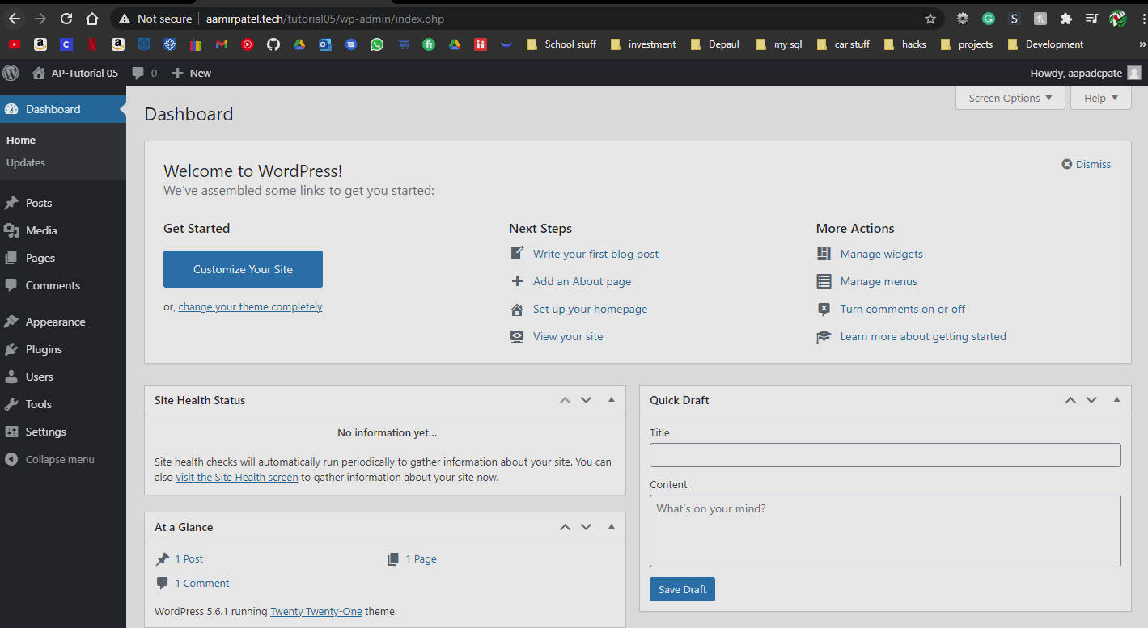]**
3. Take screen captures of the backend WordPress site Dashboard > Pages page **[B1.3]  
   [ 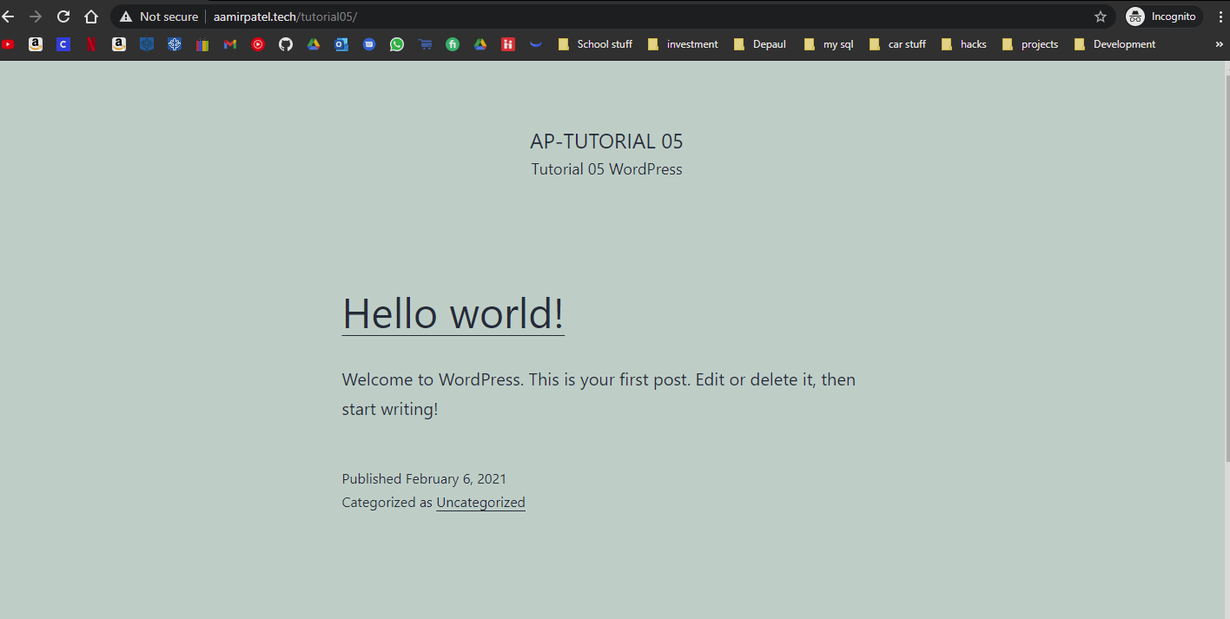]**

**- OR Pantheon-**

Part B2 – Create a WordPress site on Pantheon (PaaS)

1. Enter the following shared web host WordPress site information **[B2.1]**
   1. PaaS WordPress site Admin Username: [ website admin username here ]
   2. PaaS WordPress site Admin Password: [ website admin password here ]
   3. PaaS WordPress Front end site URL: [ website URL here ]

1. Take screen captures of the backend WordPress site Dashboard > Home page **[B2.2]  
   [ Paste screen capture here ]**
2. Take screen captures of the backend WordPress site Dashboard > Posts page **[B2.3]  
   [ Paste screen capture here ]**

**-AND Cloud, Codeanywhere-**

Part B3 – Create a WordPress site on Codeanywhere

1. Enter the following Codeanywhere web host WordPress site information **[B3.1]**
   1. Codeanywhere account username(email): [ [mpate180@depaul.edu](mailto:mpate180@depaul.edu) ]
   2. Codeanywhere account password: [ Kamboli1! ]
   3. Site Title: [ ap-–Tutorial 05 CA ]
   4. Username: [ aapadcpate ]
   5. Password: [ 9aIwR@LZB%#uk9Fgh3 ]
2. Take screen captures of the edited .htaccess file **[B3.2]  
   [ 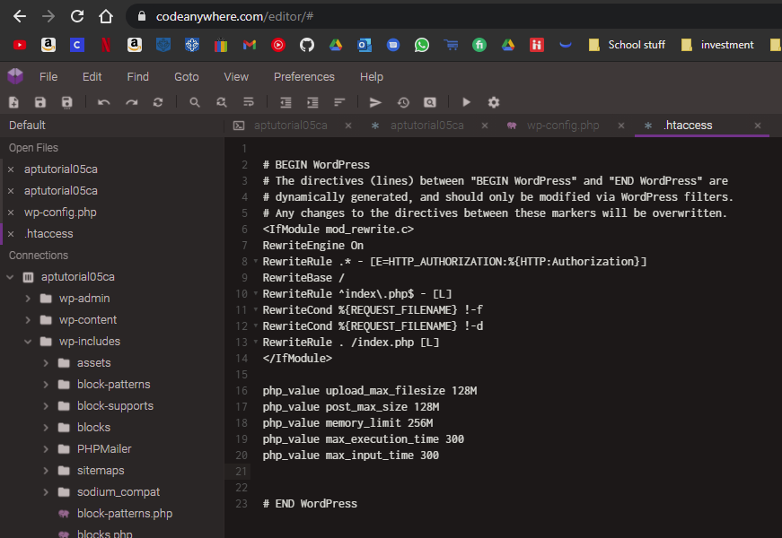 ]**
3. Take screen captures of the bottom of the edited wp-config file **[B3.3]  
   [**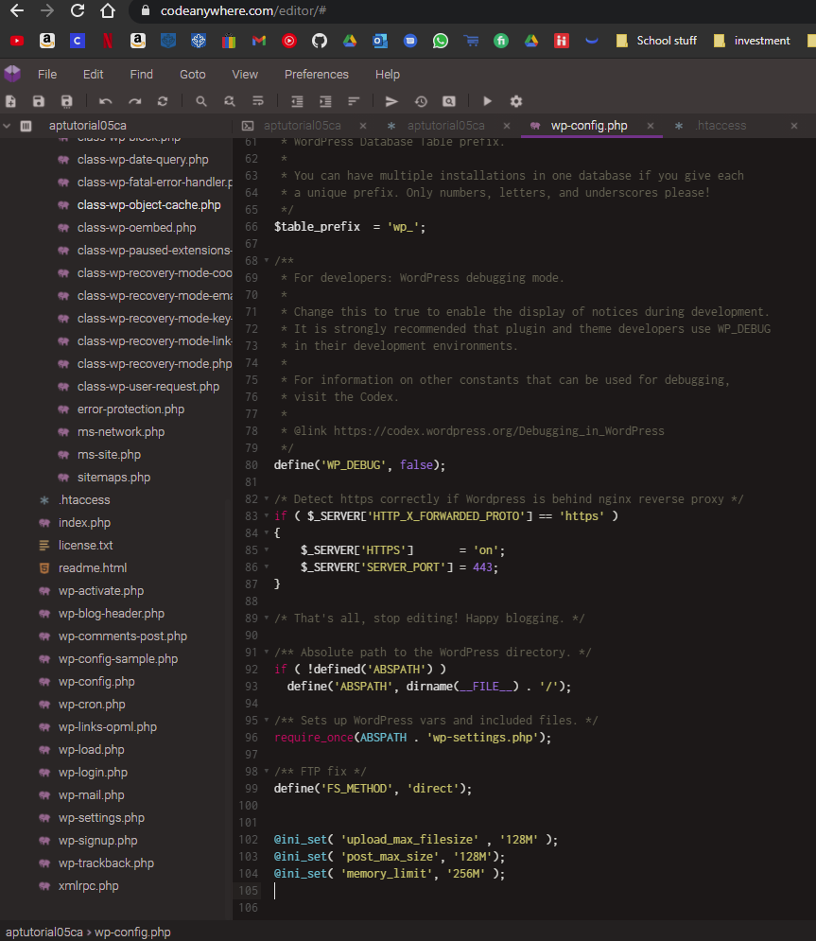

**]**

1. Take screen captures of the backend WordPress site Dashboard > Home page **[B3.4]  
   [ 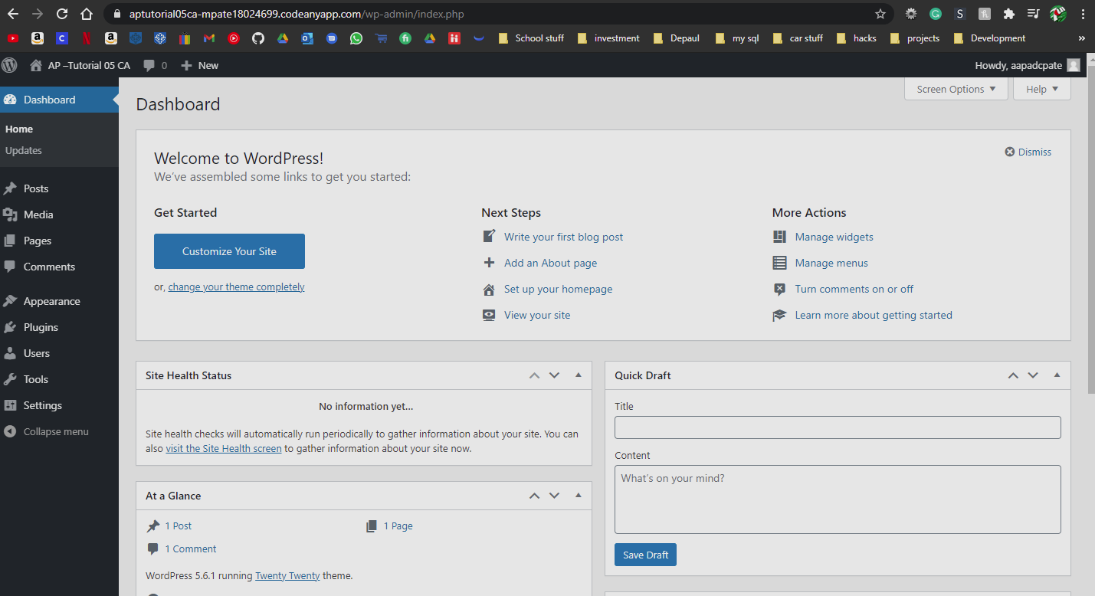]**

**Go back to the tutorial instructions and begin working on part C.**

**Part C – Extend WordPress using a [**.wpress] **All-In-One WP Migration backup file**

**Please make sure all Part C screen capture include the web browser address bar. [C]**

**Part C.1 – Imported WordPress site on a shared web host**

1. Take screen captures of the backend WordPress site Dashboard > Home page Please make sure that web browser address bar is visible as well as the Dashboard Home “At a Glance” section is expanded and visible on your screen capture.  
   **[C.1.1]  
   [ 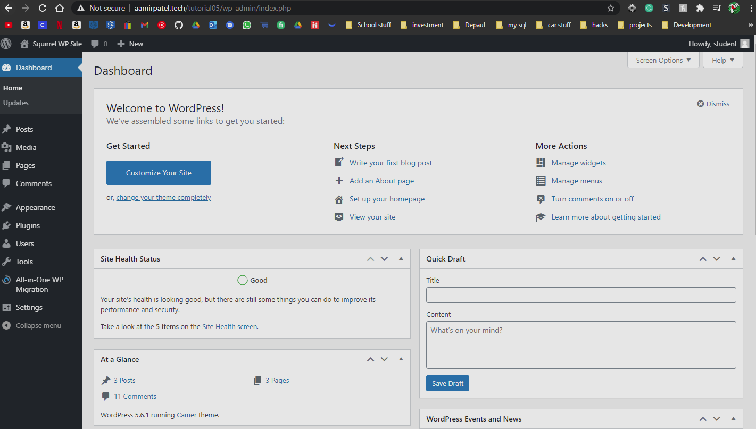]**
2. Take screen captures of the backend administration WordPress site Dashboard > Settings **[C.1.2]  
   [ 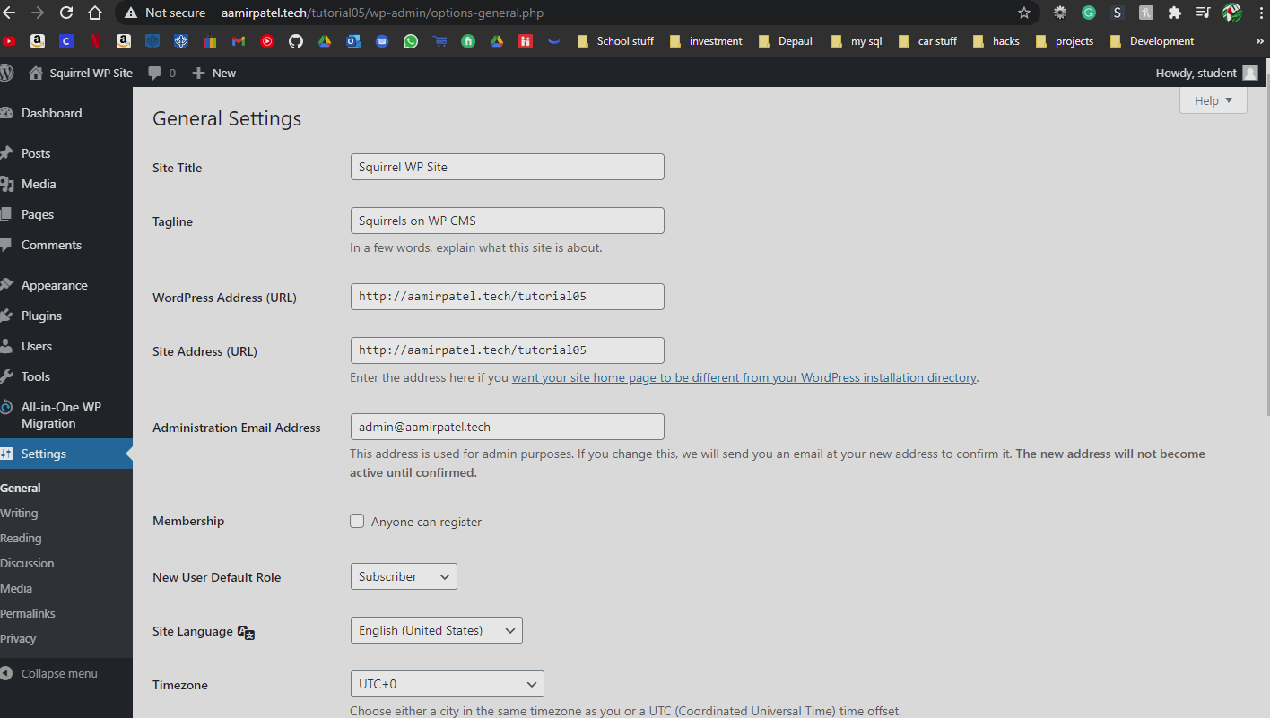 ]**
3. Take screen captures of the backend administration WordPress site Dashboard > Posts **[C.1.3]  
   [ 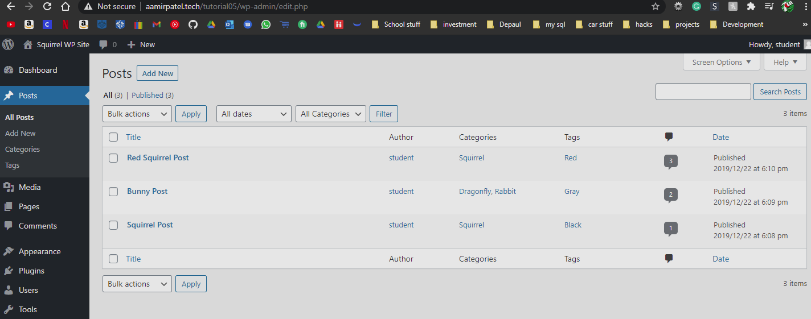]**
4. Did you change the student account password? **[C.1.4]** [ Yes ]
5. Did you add your own Account - username and password to the WordPress site?  
   **[C.1.5]  
   username: [ aapadcpate ]  
   Password: [ 9aIwR@LZB%#uk9Fgh3 ]**

**Part C.2 – Imported WordPress site on a Pantheon web host**

1. Take screen captures of the backend WordPress site Dashboard > Home page Please make sure that web browser address bar is visible as well as the Dashboard Home “At a Glance” section is expanded and visible on your screen capture.  
   **[C.2.1]  
    [ Paste screen capture here ]**
2. Take screen captures of the backend administration WordPress site Dashboard > Settings **[C.2.2]  
   [ Paste screen capture here ]**
3. Take screen captures of the backend administration WordPress site Dashboard > Posts page **[C.2.2]  
   [ Paste screen capture here ]**
4. Did you change the student account password? **[C.2.4]** [Yes or No answer here]
5. Did you add your own Account - username and password to the WordPress site?  
   **[C.2.5]  
   username: [ username here ]  
   Password: [ password here ]**

**Part C.3 – Imported WordPress site on a Codeanywhere host**

1. Take screen captures of the backend WordPress site Dashboard > Home page Please make sure that web browser address bar is visible as well as the Dashboard Home “At a Glance” section is expanded and visible on your screen capture. **[C.3.1]   
   [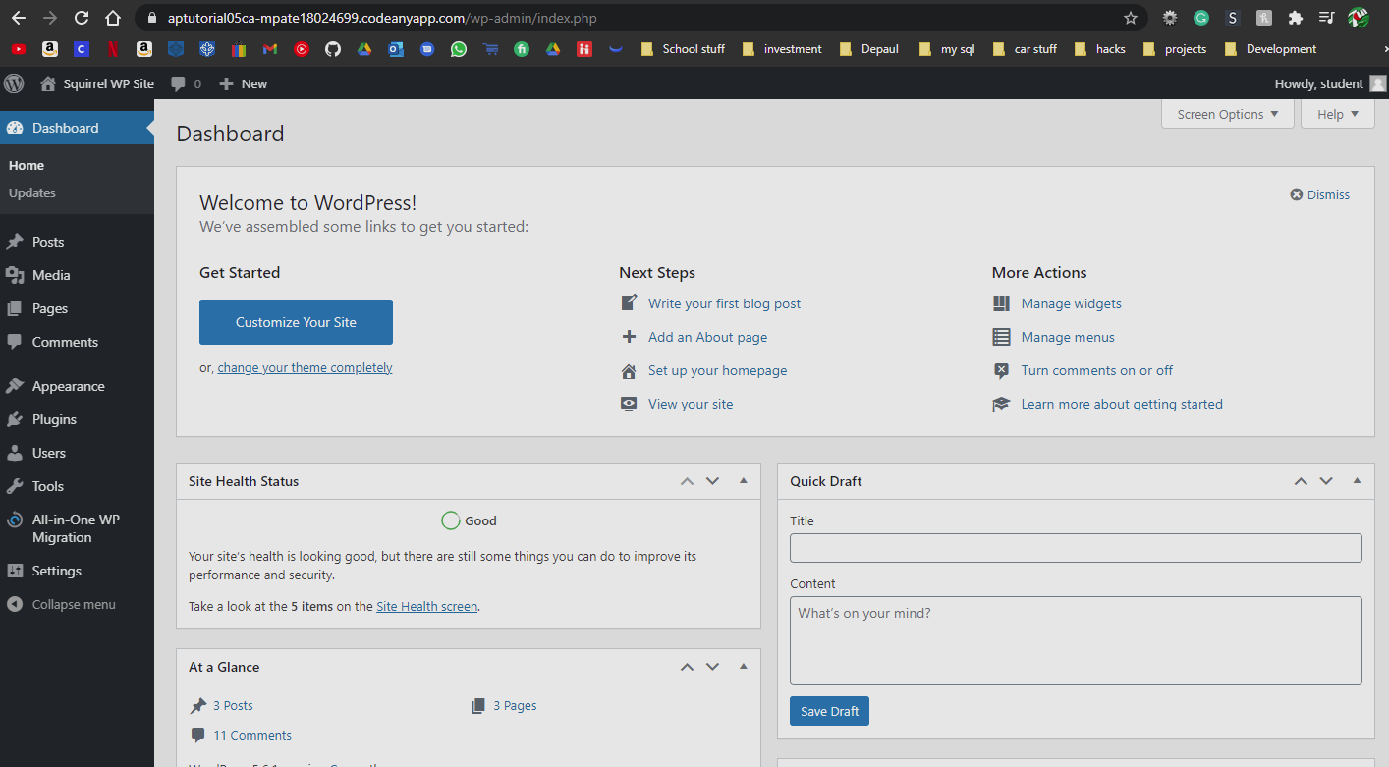]**
2. Take screen captures of the backend administration WordPress site Dashboard > Settings **[C.3.2]  
   [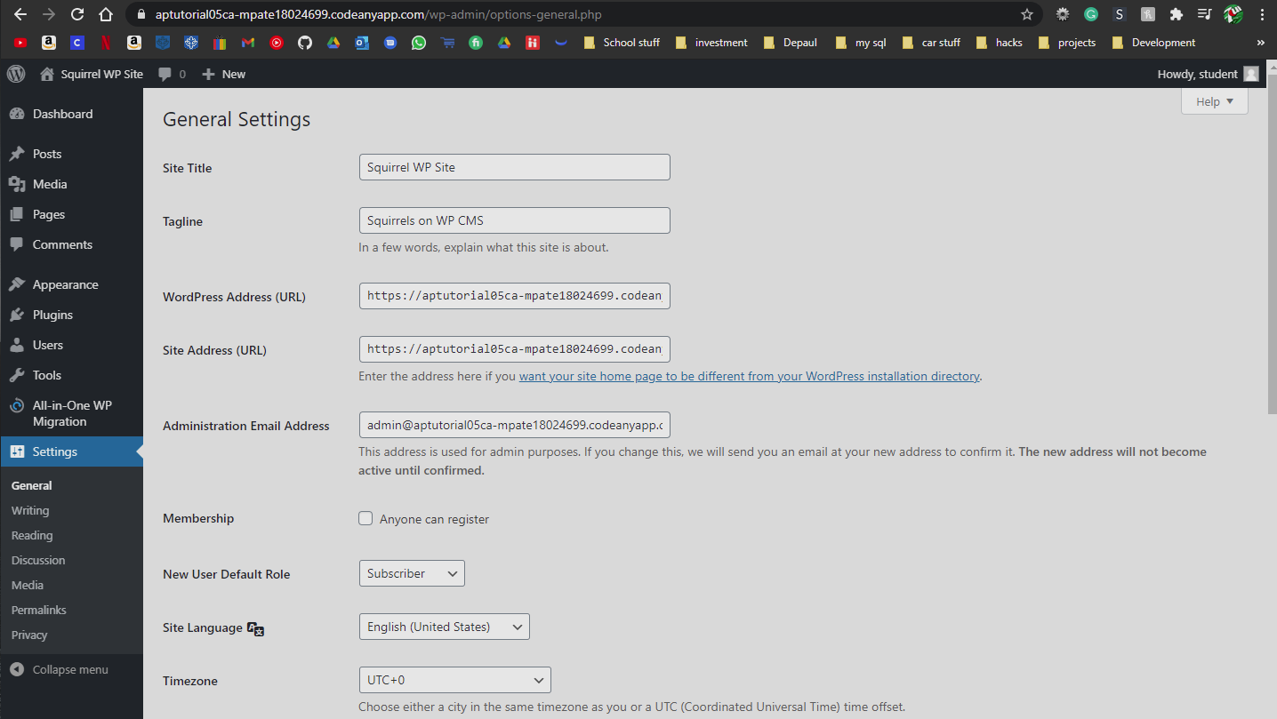]**
3. Take screen captures of the backend administration WordPress site Dashboard > Posts page **[C.3.3]  
   [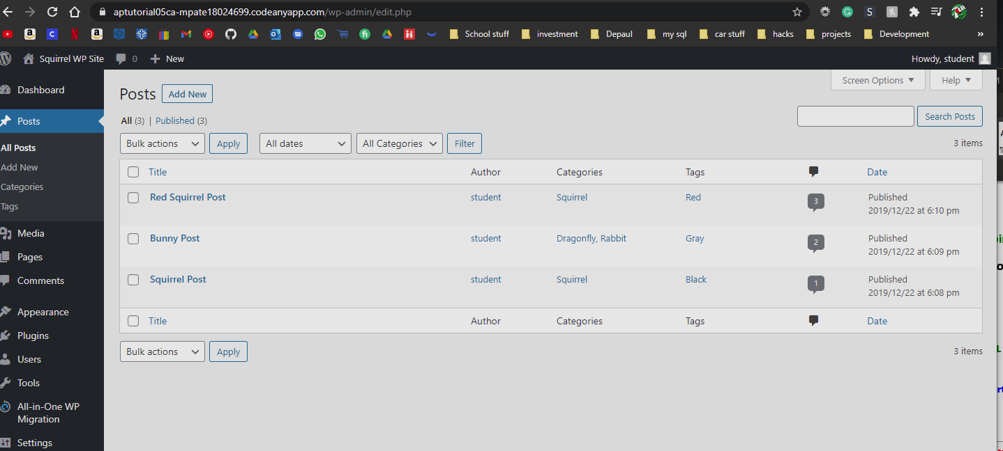]**
4. Did you change the student account password? **[C.1.4]** [ Yes ]
5. Did you add your own Account - username and password to the WordPress site?  
   **[C.1.5]  
   username: [ aapadcpate ]  
   Password: [ 9aIwR@LZB%#uk9Fgh3 ]**

**Go back to the instructions and continue at Part D.**

**Part D – Introduction to phpMyAdmin**

**Please make sure all Part D screen capture include the web browser address bar. [D]**

D.1 Shared Web Host - Access phpMyAdmin on your shared web host

1. Select the current WordPress site’s MySQL Database
2. Select the Person table and take a screen capture of its structure **[D.1.1]  
   [** 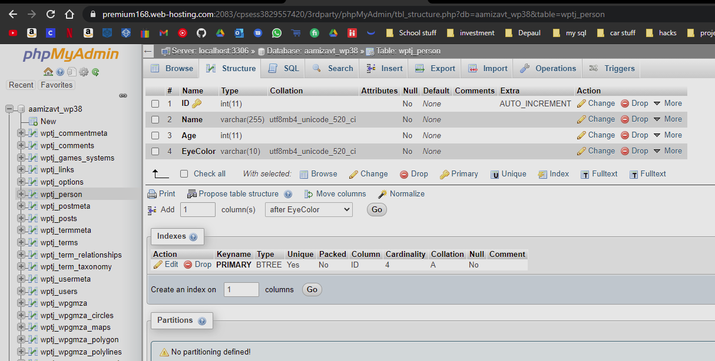
3. Select the Person table and take a screen capture of its data (records) **[D.1.2]  
   [ 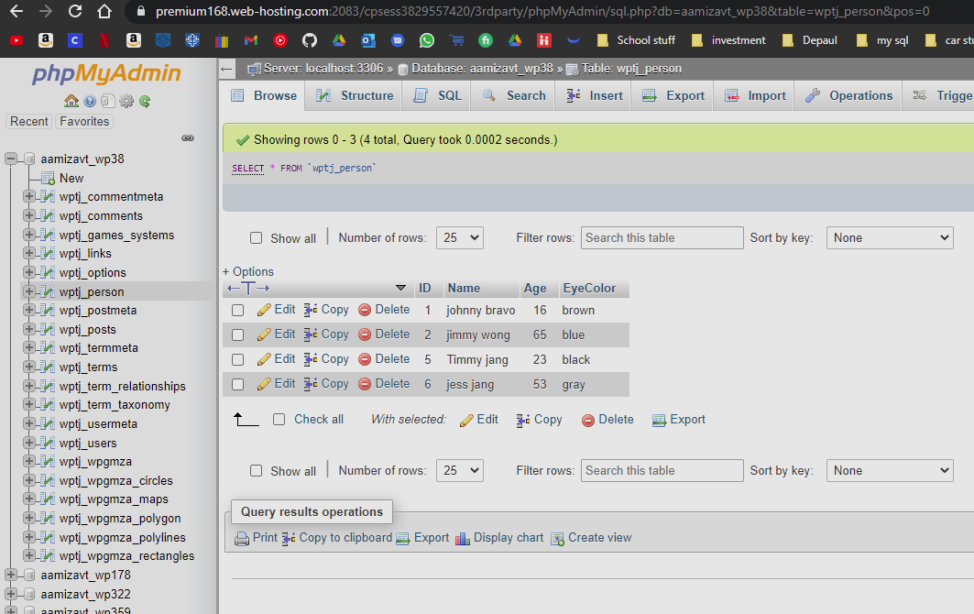]**

D.2 Pantheon - Access MySQL Workbench on your local computer

1. Connect to your Pantheon WP site’s MySQL database
2. Select the Person table and take a screen capture of its structure **[D.2.1]  
   [ Paste screen capture here ]**
3. Select the Person table and take a screen capture of its data (records) **[D.2.2]  
   [ Paste screen capture here ]**

D.3 Shared Web Host - Access phpMyAdmin on your Codeanywhere account

1. Select the current WordPress site’s MySQL Database
2. Select the Person table and take a screen capture of its structure **[D.3.1]  
   [ 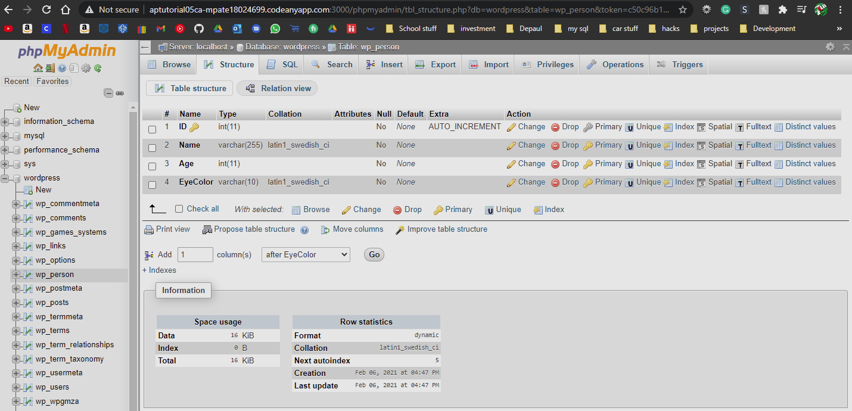]**
3. Select the Person table and take a screen capture of its data (records) **[D.3.2]  
   [ 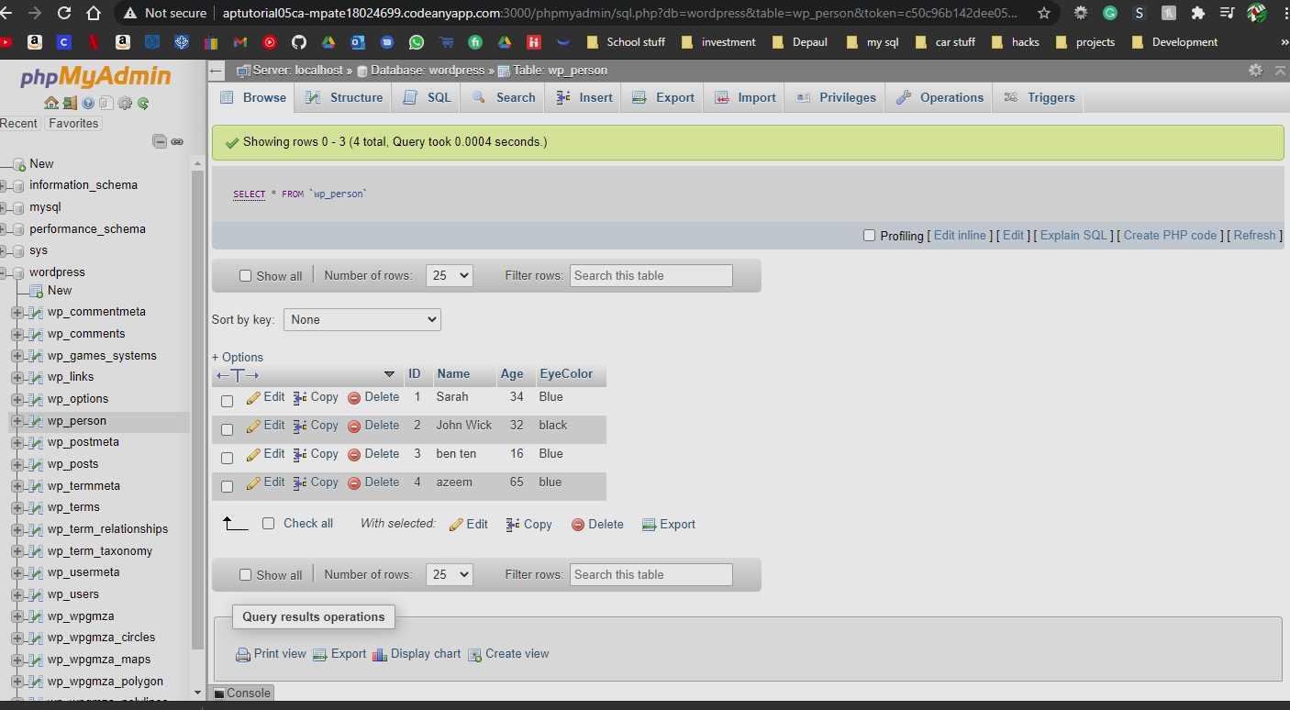]**

**Go back to the instructions and continue at Part E.**

**Part E – Improve WordPress site security**

**Please make sure all Part E screen capture include the web browser address bar. [E]**

1. What 5 steps should you take to enhance your WordPress site security **[E.1]  
   [**

* Keep site and system up to date.
* Delete Wp admin accounts with the username admin.
* Restrict File Access
* Perform Frequent Backups

**]**

1. Which is more secure, forcing your users to use strong passwords or Two Factor Authentication and why? **[E.2]**

**[** Two Factor Authentication **]**

1. What exactly does it mean (what do you do) to keep your WordPress environment up to date? **[E.3]**

**[** This means keeping your wordpress version, files, and plugins upto date.**]**

1. Why is it so important to keep your WordPress environment up to date? **[E.4]**

**[** Because there might be a issue with the old version that is fixed in the new one**]**

1. Why is it so important to always have a viable backup copy of your WordPress site and a well-documented and tested disaster recovery protocol? **[E.5]**

**[**Because if something happens like you got hacked, or your site goes down due to a bad plugin, you can go to one of your backups and update your site. Disaster recovery protocol is important because you don’t want to test if your disaster recovery protocol works when your website is down. Basically you don’t want to assume or guess that your disaster recovery protocol works.**]**

**Go back to the instructions and continue at Part F.**

**Part F – Extend WordPress custom Plugins**

**Please make sure all Part F screen capture include the web browser address bar.   
The Classic Editor should have been included with the WP site import.   
It should be in a disabled state. If it is not disabled, please disable and delete it now.  
Do not enable the Classic Editor plugin.  
We do not want the Classic Editor enabled as we want to create Gutenberg compatible WP plugins.**

F.1-F.2 Review the Module 05 D2L Presentation  
 **F.3 Shared Web Host Custom Plugin – Posts Reader**

1. Take screen captures of the backend administration WordPress site Dashboard > Plugins page showing the Classic Editor Plugin not listed (not installed)   
   **[F.3.1]  
   [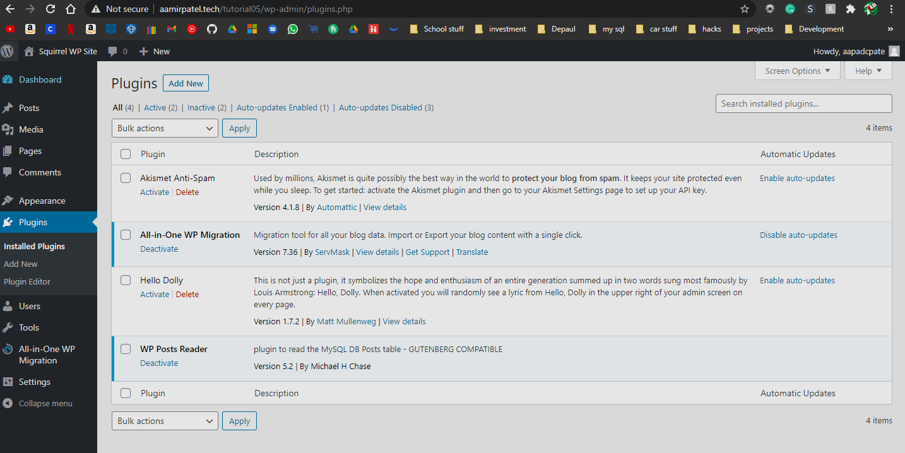]**
2. From the Dashboard, select Pages. Select Edit for Post Test Page and take a screen capture of the Test Page Template **[  
   F.3.2]  
   [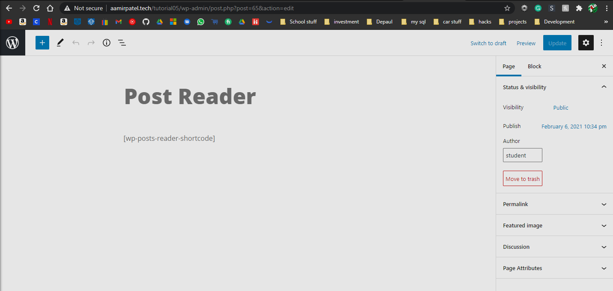]**
3. Take screen captures of the frontend client facing WordPress site showing the menu and   
   Post Test Page menu item selected   
   **[F.3.3]  
   [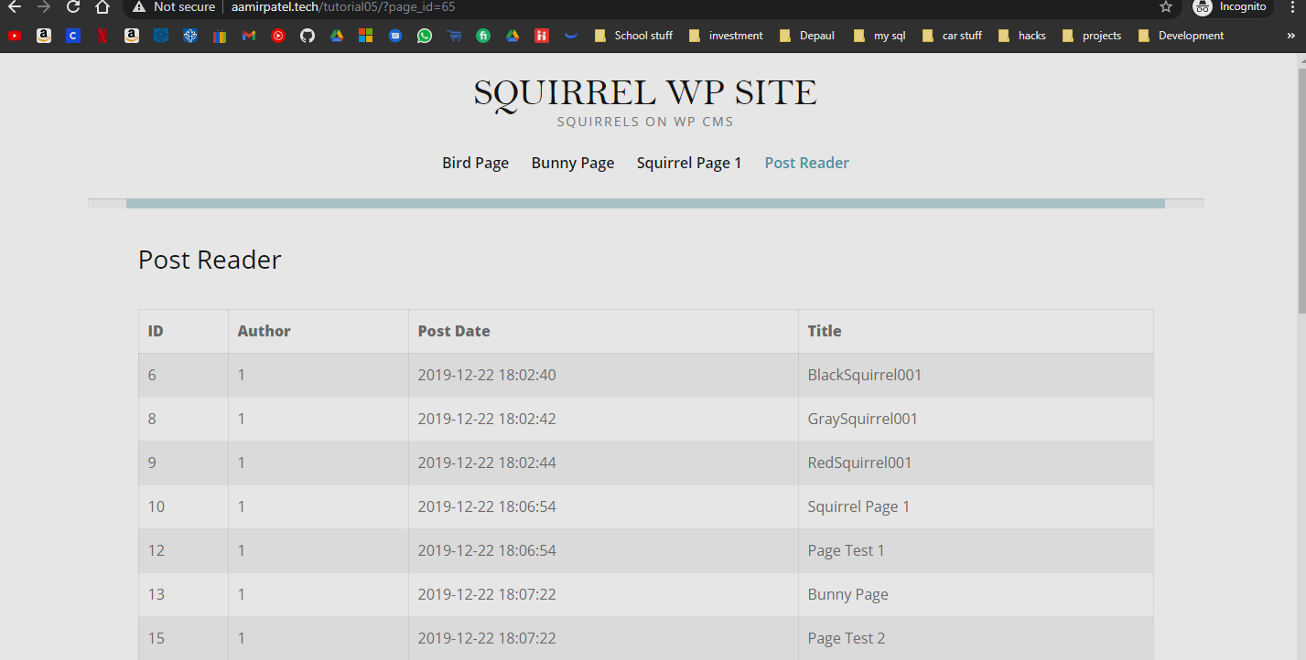]**

**F.4 Pantheon Custom Plugin – Posts Reader**

1. Take screen captures of the backend administration WordPress site Dashboard > Plugins page showing the Classic Editor Plugin not installed  
    **[F.4.1]  
   [Paste screen capture here]**
2. From the Dashboard, select Pages. Select Edit for Post Test Page and take a screen capture of the Test Page Template **[F.4.2]  
   [Paste screen capture here]**
3. Take screen captures of the frontend client facing WordPress site showing the menu and   
   Post Test Page menu item selected **[F.4.3]  
   [Paste screen capture here]**

**F.5 Codeanywhere Custom Plugin – Comments Reader**

1. Take screen captures of the backend administration WordPress site Dashboard > Plugins page showing the Classic Editor Plugin is not installed  
    **[F.5.1]  
   [ 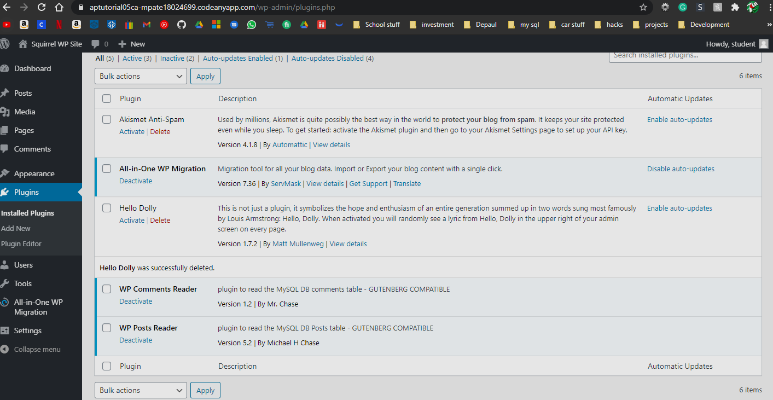 ]**
2. From the Dashboard, select Pages. Select Edit for the Comments Reader custom plugin page and take a screen capture of the Test Page Template **[F.5.2]  
   [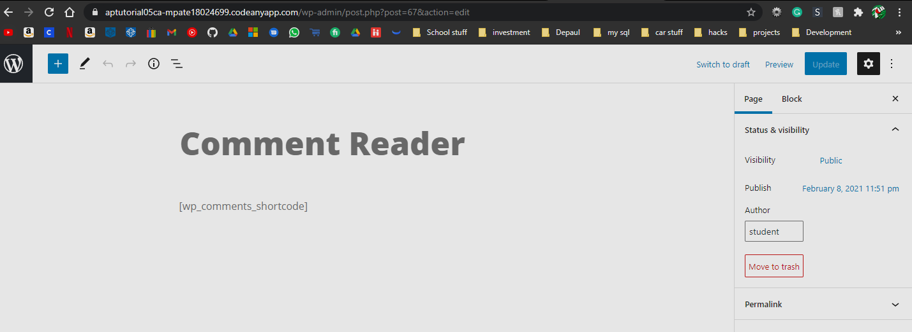]**
3. Take screen captures of the frontend client facing WordPress site showing the menu and   
   Comments Reader custom plugin menu item selected **[F.5.3]  
   [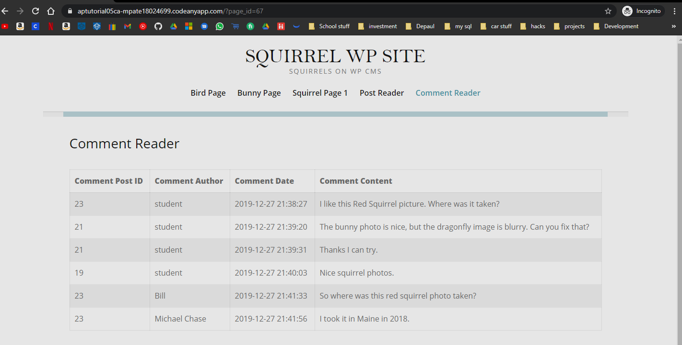]**

**Go back to the instructions and continue at Part G.**

**Part G – GitHub Workflow**

**Please make sure all Part G screen capture include the web browser address bar. [G]**

1. Take a screen capture of your GitHub.com Account main page **[G.1]  
   [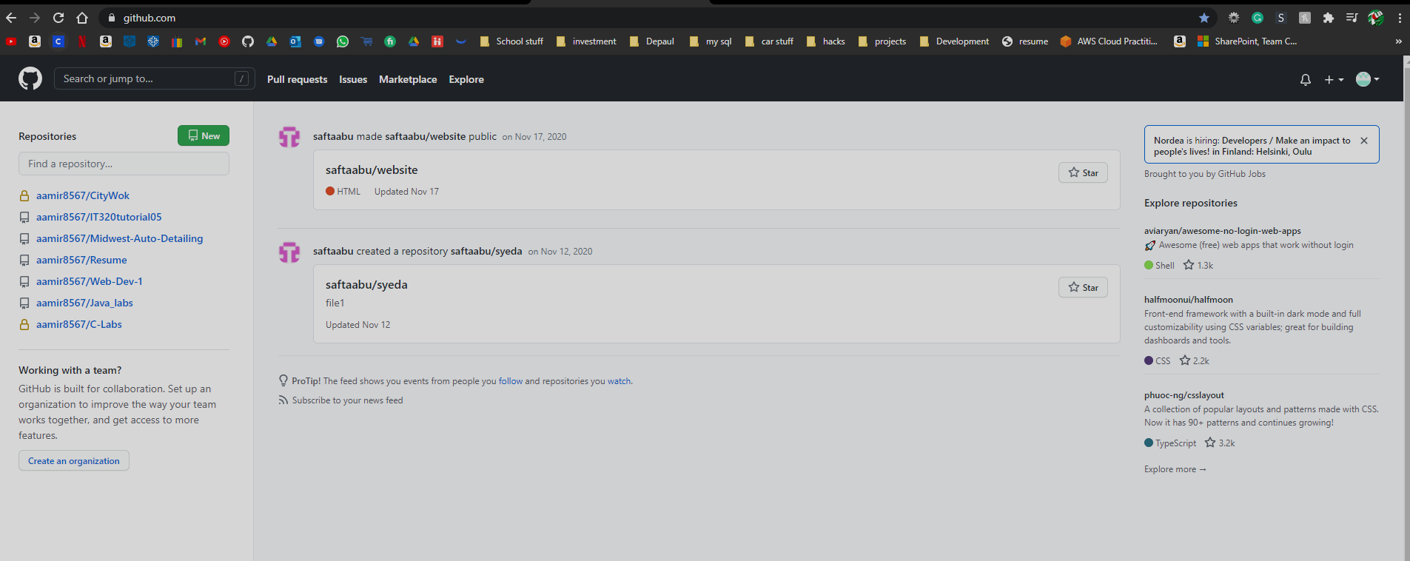]**
2. Take a screen capture of your GitHub.com Account Your Repos Page **[G.2]  
   [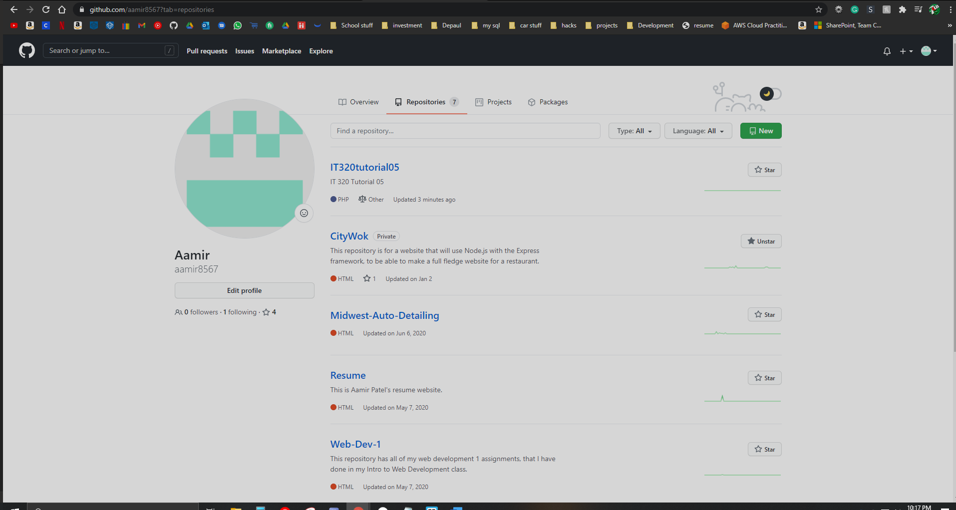]**
3. Select your Tutorial 05 Repo and Take a screen capture of its contents.   
   This may take more than one screen capture **[G.3]  
   [**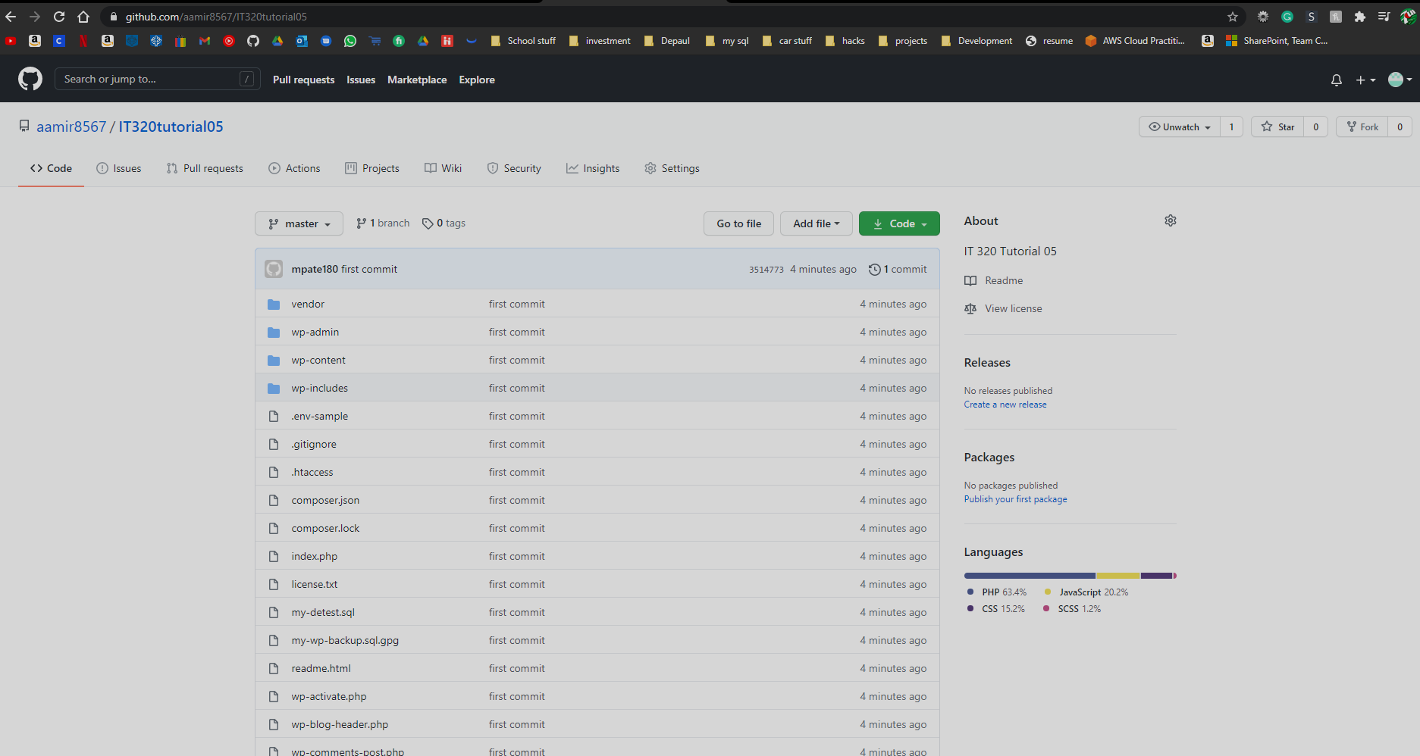

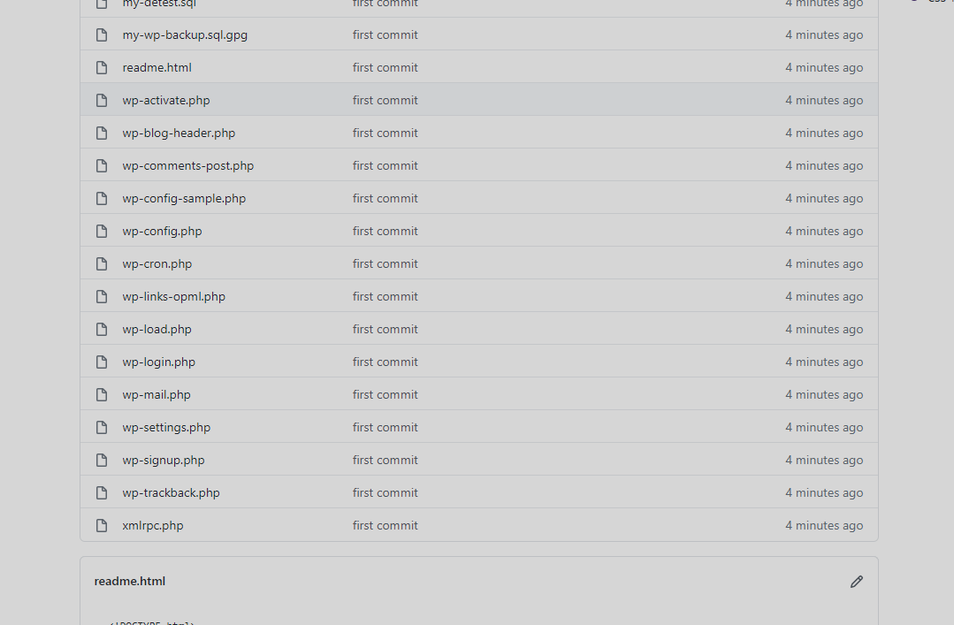

**]**

**Go back to the instructions and continue at Part H.**

**Part H – PHP QUESTIONS**

**Testing PHP Programs using PHP Emulation Websites:**

* Online PHP test sites:
  + <http://phptester.net>
  + <http://sandbox.onlinephpfunctions.com/>
* How you test your script depends on which test site you use.
* **Each PHP emulation test site works slightly different**.
* Please read the site instructions before testing your PHP code.

1. Write and test PHP code that uses the sizeof prewritten function to get the size of a PHP array or integers and then echo out the size of the array:
   1. Create a PHP integer array of 7 integers.
   2. Write a PHP statement that uses the sizeof function to get the size of the array and assigns the size to a variable named $sizeOfAarray.
   3. Echo out the $sizeOfAarray value.
   4. **Test your code using an online PHP emulator and paste the code and results in the table cell below.**

|  |
| --- |
| Copy and paste the code block and record the results on the next row. A screen shot from the PHP test site will be the best way to not affect template format. Please try not to change the template numbering or format. |
|  |

1. Write and test PHP code that uses the gettype prewritten function to get the variable data types of 6 different variable data types:
2. Create 6 variables with the flowing names and values:
   1. $cars = array(‘Ford’, ‘Mazda’, ‘Telsa’);
   2. $name = “Bill”;
   3. $age = 35;
   4. $weight = 189.35;
   5. $isTrue = false;
   6. $carsAssocArray = array('a' => 'Alpha', 'B' => 'Bentley');
3. Write a PHP statement that uses the gettype function to get the data types of each variable and on the same line, echo out the value of the return value of the call to the gettype function call.
   1. Example: echo gettype( $variableNameHere) . “<br>”;
4. **Test your code using an online PHP emulator and paste the code and results in the table cell below.**

|  |
| --- |
| Copy and paste the code block and record the results on the next row. A screen shot from the PHP test site will be the best way to not affect template format. Please try not to change the template numbering or format. |
|  |

1. Write and test PHP code that uses the strlen prewritten function to get the length of a PHP string variable then echo out the length of the string:
   1. Create a PHP variable with a string value of at least 10 characters.
   2. Write a PHP statement that uses the strlen function to get the length of the string and echo out the value.
   3. **Test your code using an online PHP emulator and paste the code and results in the table cell below.**

|  |
| --- |
| Copy and paste the code block and record the results on the next row. A screen shot from the PHP test site will be the best way to not affect template format. Please try not to change the template numbering or format. |
|  |

1. Write and test PHP code that uses the strlen prewritten function to get the length of a PHP string variable then echo out the length of the string:
   1. Create a PHP variable with a string value of at least 5 characters with 5 spaces at the front of the string and 5 spaces at the end of the string.
      1. Example: $a = “ cccccc “;
   2. Write a PHP statement that uses the strlen and trim functions to get the length of the string before and after calling the trim function and echo out the values.
   3. **Test your code using an online PHP emulator and paste the code and results in the table cell below.**

|  |
| --- |
| Copy and paste the code block and record the results on the next row. A screen shot from the PHP test site will be the best way to not affect template format. Please try not to change the template numbering or format. |
|  |

1. Write and test PHP code that uses the print_r prewritten function to print out the values of an integer variable, a string variable, and integer array variable and an associative array variable. **Test your code using an online PHP emulator and paste the code and results in the table cell below.**

|  |
| --- |
| Copy and paste the code block and record the results on the next row. A screen shot from the PHP test site will be the best way to not affect template format. Please try not to change the template numbering or format. |
|  |

1. Write and test PHP code that uses the empty prewritten function to evaluate string variables with and without length and only print out the values of stings that are not empty.   
   **Test your code using an online PHP emulator and paste the code and results in the table cell below.**

|  |
| --- |
| Copy and paste the code block and record the results on the next row. A screen shot from the PHP test site will be the best way to not affect template format. Please try not to change the template numbering or format. |
|  |

Please go back to the tutorial instructions and start work on Part I.